E-COMMERCE SALES & CUSTOMER ANALYTICS
  - A Data-Driven Business Analysis Using SQL, Power BI & Excel
Tools Used
Excel | Power Query | MySQL | SQL | Power BI
August2026
Prepared by
MOHAMMED RINSHID K

Contents
ECUTIVE SUMMARY 6
Project Overview 6
Analytical Approach 6
Key Findings 6
Business Value 7
BUSINESS PROBLEM 8
PROJECT OBJECTIVES 9
PROJECT SCOPE 10
DATASET DESCRIPTION 11
Customers Table 11
Products Table 11
Orders Table 12
Order Details Table 12
DATA UNDERSTANDING & EXPLORATION 13
Data Quality Checks 13
Duplicate Records 13
Missing Values 13
Text Consistency 13
Date Formatting 14
Numerical Validation 14
DATA CLEANING & TRANSFORMATION 15
Power Query 15
Data Transformation Process 15
DATA MODELING 16
Data Model 16
Relationship Structure 16
Relationships 16
SQL ANALYSIS 18
SQL Analysis Overview 18
SQL Techniques Used 18
Root Cause Analysis Using SQL 19
EXPLORATORY DATA ANALYSIS 20
Sales Analysis 20
Profitability Analysis 20
Customer Analysis 20
Operational Analysis 20
KPI ANALYSIS 21
POWER BI DASHBOARD DEVELOPMENT 22
EXECUTIVE SALES DASHBOARD 22
Main Components 22
22
Dashboard Purpose 22
PROFITABILITY & CUSTOMER INSIGHTS DASHBOARD 23
Main Components 23
23
BUSINESS INSIGHTS 24
Sales Performance 24
Total Sales Reached 5.82M 24
Total Profit Reached 1.35M 24
Electronics Generated the Highest Sales 24
Central Region Recorded the Highest Sales 24
August Recorded the Highest Monthly Sales 24
Profitability 24
Electronics Generated the Highest Profit 24
Central Region Generated the Highest Profit 25
Sales and Profit Show a Similar Monthly Trend 25
Profit Contribution Varies Across Product Categories 25
Average Order Value is 72.69K 25
Customer & Operations 25
The Business Has 80 Recorded Customers 25
The Dataset Contains 80 Recorded Orders 25
Total Quantity Sold is 341 Units 26
Return Rate is 21% 26
I Cancellation Rate is 10% 26
ROOT CAUSE ANALYSIS 27
Electronics Generated the Highest Sales 27
Business Finding 27
RCA Investigation 27
Root Cause 27
Business Implication 27
Central Region Recorded the Highest Sales 27
Business Finding 27
RCA Investigation 27
Root Cause 27
Business Implication 28
August Recorded the Highest Monthly Sales 28
Business Finding 28
RCA Investigation 28
Root Cause 28
Business Implication 28
Electronics Generated the Highest Profit 28
Business Finding 28
RCA Investigation 28
Root Cause 28
Business Implication 29
Central Region Generated the Highest Profit 29
Business Finding 29
RCA Investigation 29
Root Cause 29
Business Implication 29
Profit Contribution Varied Across Product Categories 29
Business Finding 29
RCA Investigation 29
Root Cause 29
Business Implication 30
Return Rate Was 21% 30
Business Finding 30
RCA Investigation 30
Root Cause 30
Business Implication 30
Cancellation Rate Was 10% 30
Business Finding 30
RCA Investigation 30
Root Cause 31
Business Implication 31
BUSINESS RECOMMENDATIONS 32
Strengthen High-Performing Electronics Products 32
Based on Finding 32
Recommendation 32
Expected Business Impact 32
Reduce Customer Concentration in the Central Region 32
Based on Finding 32
Recommendation 32
Expected Business Impact 32
Replicate August's High-Performing Sales Patterns 32
Based on Finding 32
Recommendation 33
Expected Business Impact 33
Focus on High-Profit Products 33
Based on Finding 33
Recommendation 33
Expected Business Impact 33
Diversify High-Profit Customer Contributions in Central 33
Based on Finding 33
Recommendation 33
Expected Business Impact 33
Replicate High-Profit Product Characteristics across Categories 34
Based on Finding 34
Recommendation 34
Expected Business Impact 34
Investigate High Return Risk in the West Region 34
Based on Finding 34
Recommendation 34
Expected Business Impact 34
Reduce Order Cancellations in the Central Region 35
Based on Finding 35
Recommendation 35
Expected Business Impact 35
CONCLUSION 36
LIMITATIONS 37
Dataset Size 37
Limited Historical Coverage 37
Return and Cancellation Reasons 37
Small Sample Size for Payment Analysis 37
Synthetic / Portfolio Dataset 37
FUTURE SCOPE 38
Sales Forecasting 38
Customer Segmentation 38
Customer Lifetime Value 38
Predictive Return Analysis 38
Cancellation Prediction 38
Advanced Profitability Analysis 38
Inventory Optimization 38
Automated Reporting 38

ECUTIVE SUMMARY

Project Overview
The E-Commerce Sales & Customer Analytics project focuses on analysing e-commerce transactional data to understand sales performance, profitability, customer behaviour, product performance, regional performance, and operational issues.
The project transforms raw transactional data into meaningful business insights through a structured data analytics workflow involving Excel, Power Query, SQL, Power BI, and DAX.
The analysis was designed to answer important management questions such as which products and categories generate the highest sales and profit, which regions perform best, how sales and profit change over time, and where operational issues such as returns and cancellations require attention.

Analytical Approach
The project followed a complete data analytics lifecycle:
Raw Data → Data Understanding → Data Cleaning → Data Transformation → Data Modelling → SQL Analysis → EDA → KPI Analysis → Power BI Visualization → Business Insights → Root Cause Analysis → Business Recommendations
Power Query was used for data cleaning and transformation, while SQL was used for detailed analytical queries and Root Cause Analysis. Power BI and DAX were used to calculate key performance indicators and develop interactive dashboards.

Key Findings
The analysis identified several important business findings:
- Total Sales reached 5.82M.
- Total Profit reached 1.35M.
- Overall Profit Margin was approximately 23%.
- Electronics generated the highest sales and profit.
- The Central region recorded the highest sales and profit.
- August recorded the highest monthly sales.
- Average Order Value was 72.69K.
- The business recorded 21% Return Rate.
- The Cancellation Rate was 10%.
- Several high-performing products and customers were found to contribute significantly to regional and category performance.

Business Value
The analysis provides management with a clearer understanding of revenue drivers, profitable products, regional performance, customer concentration, and operational risks.
The findings can support better decisions related to inventory planning, product prioritization, customer acquisition, sales strategy, profitability management, and operational improvement.

BUSINESS PROBLEM
E-commerce businesses generate large amounts of transactional data through customer orders, products, payments, and order fulfilment activities.
However, raw transaction data alone does not provide management with a clear understanding of business performance.
The key challenge addressed in this project is to transform transactional e-commerce data into actionable information that can support business decision-making.
The analysis focuses on identifying:
- Overall sales performance
- Revenue and profit performance
- Monthly sales and profit trends
- Product and category performance
- Regional performance
- Customer contribution
- Average order value
- Return patterns
- Cancellation patterns
- Profitability differences
- Operational improvement opportunities
The project therefore aims to answer the following core business question:
How can e-commerce transactional data be analysed to identify revenue drivers, profitability opportunities, customer and regional patterns, and operational issues that support better business decisions?

PROJECT OBJECTIVES
The primary objectives of this project are:
- To analyse overall e-commerce sales performance.
- To measure total sales and total profit.
- To calculate key financial and operational KPIs.
- To identify the highest-performing product categories.
- To identify top-performing products.
- To analyse regional sales and profitability.
- To identify monthly sales and profit trends.
- To analyse customer contribution and customer concentration.
- To evaluate product profitability.
- To analyse order status, returns, and cancellations.
- To identify potential operational problem areas.
- To perform Root Cause Analysis using SQL.
- To develop interactive Power BI dashboards.
- To convert analytical findings into actionable business recommendations.
- To demonstrate an end-to-end practical data analytics workflow.

PROJECT SCOPE
The scope of this project covers the analysis of e-commerce sales and customer transaction data.
The analysis includes four primary datasets:
- Customers
- Products
- Orders
- Order Details
The project covers data preparation, data modelling, SQL analysis, KPI calculation, visualization, business insights, Root Cause Analysis, and recommendations.
The project does not attempt to build predictive models or machine learning solutions. Instead, it focuses primarily on descriptive and diagnostic analytics to understand what happened and why certain patterns occurred within the available dataset.

DATASET DESCRIPTION

The dataset consists of four interconnected tables representing different aspects of an e-commerce business.

Table | Description
Customers | Contains customer-related information
Products | Contains product, category, selling price and cost information
Orders | Contains order-level transaction information
Order Details | Contains individual products and quantities associated with orders

Customers Table
The Customers table contains information related to customers.
Important fields include:
- Customer ID
- Customer Name
- Region
- Customer-related attributes
The Customer ID serves as the primary identifier for customers.

Products Table
The Products table contains information about products sold by the business.
Important fields include:
- Product ID
- Product Name
- Category
- Selling Price
- Cost Price
The Product ID uniquely identifies each product.

Orders Table
The Orders table contains order-level information.
Important fields include:
- Order ID
- Customer ID
- Order Date
- Payment Method
- Order Status
- Region-related information
The Order ID uniquely identifies each order.

Order Details Table
The Order Details table contains product-level transaction information.
Important fields include:
- Order ID
- Product ID
- Quantity
This table connects individual orders with the products purchased in those orders.

DATA UNDERSTANDING & EXPLORATION

The first stage of the project involved understanding the structure and characteristics of the raw dataset.
The four tables were reviewed to understand:
- Number of records
- Column names
- Data types
- Primary keys
- Foreign keys
- Missing values
- Duplicate records
- Inconsistent text values
- Date formatting
- Numerical fields
- Relationships between tables
Initial exploration helped identify data quality issues that needed to be addressed before performing analytical calculations.

Data Quality Checks
The following checks were performed:

Duplicate Records
The datasets were reviewed for duplicate identifiers and duplicate records.

Missing Values
Columns were checked for missing or blank values that could affect analysis.

Text Consistency
Text fields were reviewed for inconsistent capitalization and formatting.
For example, order status values such as:
Delivered
And
Delivered
Needed to be standardized.

Date Formatting
Date fields were reviewed and standardized to ensure that time-based analysis could be performed correctly.

Numerical Validation
Price, cost, quantity, and other numerical fields were reviewed to ensure that they were suitable for analysis.

DATA CLEANING & TRANSFORMATION

Power Query
Power Query was used to clean and transform the raw data before analysis.
The main data preparation activities included:
- Removing duplicate records
- Handling missing values
- Standardizing text values
- Correcting inconsistent capitalization
- Formatting date columns
- Validating numerical fields
- Checking identifiers
- Preparing tables for data modelling

Data Transformation Process
The transformation process followed:
Raw Data
↓
Power Query
↓
Data Cleaning
↓
Data Standardization
↓
Data Validation
↓
Clean Dataset
The cleaned data was then used for data modelling and subsequent analysis.

DATA MODELING

Data Model
A relational data model was created in Power BI to connect the four tables.
The model follows a structure where transactional order information is connected with customer, product, and order-detail information.

Relationship Structure
Customers
↓
Orders
↓
Order Details
↑
Products

Relationships
The following relationships were established:
From Table | Column | To Table | Column | Relationship
Customers | Customer ID | Orders | Customer ID | 1 : Many
Orders | Order ID | Order Details | Order ID | 1 : Many
Products | Product ID | Order Details | Product ID | 1 : Many

These relationships allow information from customers and products to flow into transaction-level analysis.
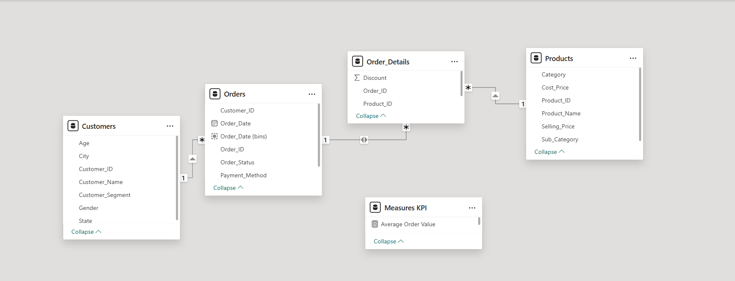

SQL ANALYSIS

SQL Analysis Overview
SQL was used as a major analytical tool in this project.
A total of 25 SQL queries were developed to answer different business questions.
The SQL analysis covered:
- Total sales
- Total profit
- Sales by category
- Sales by region
- Product performance
- Customer performance
- Monthly trends
- Payment-method analysis
- Order-status analysis
- Return analysis
- Cancellation analysis
- Profitability analysis

SQL Techniques Used
The analysis involved SQL techniques such as:
- SELECT
- WHERE
- GROUP BY
- ORDER BY
- SUM()
- COUNT()
- AVG()
- DISTINCT
- CASE
- JOIN
- Aggregation
- Filtering
- Ranking
- Percentage calculations

Root Cause Analysis Using SQL
SQL was also used for diagnostic analysis to investigate the reasons behind major business findings.
The Root Cause Analysis examined relationships between:
- Products
- Categories
- Regions
- Customers
- Payment Methods
- Order Status
- Sales
- Profit
- Returns
- Cancellations
This helped move the analysis beyond simply identifying what happened to investigating why it happened.

EXPLORATORY DATA ANALYSIS
Exploratory Data Analysis was performed to identify important patterns and relationships within the dataset.
The analysis focused on:

Sales Analysis
- Overall sales performance
- Monthly sales trends
- Category-level sales
- Regional sales
- Product-level sales

Profitability Analysis
- Overall profit
- Profit by category
- Profit by region
- Product profitability
- Profit margin

Customer Analysis
- Customer contribution
- Top customers
- Customer concentration
- Regional customer behaviour

Operational Analysis
- Order status
- Returns
- Cancellations
- Payment methods
The results of the exploratory analysis were subsequently visualized through Power BI dashboards.

KPI ANALYSIS

The following key performance indicators were calculated using DAX in Power BI.
KPI | Result
Total Sales | 5.82M
Total Profit | 1.35M
Profit Margin | 23%
Total Orders | 80
Total Quantity Sold | 341
Average Order Value | 72.69K
Total Customers | 80
Average Selling Price | 16.41K
Return Rate | 21%
Cancellation Rate | 10%

POWER BI DASHBOARD DEVELOPMENT

Two Power BI dashboards were developed to present the results in an interactive and management-friendly format.

EXECUTIVE SALES DASHBOARD
The Executive Sales Dashboard provides an overview of the company's sales performance.

Main Components
- Total Sales
- Total Profit
- Profit Margin
- Total Orders
- Total Quantity Sold
- Monthly Sales Trend
- Sales by Category
- Sales by Region
- Top 10 Products
- Sales vs. Profit Trend
- Interactive slicers
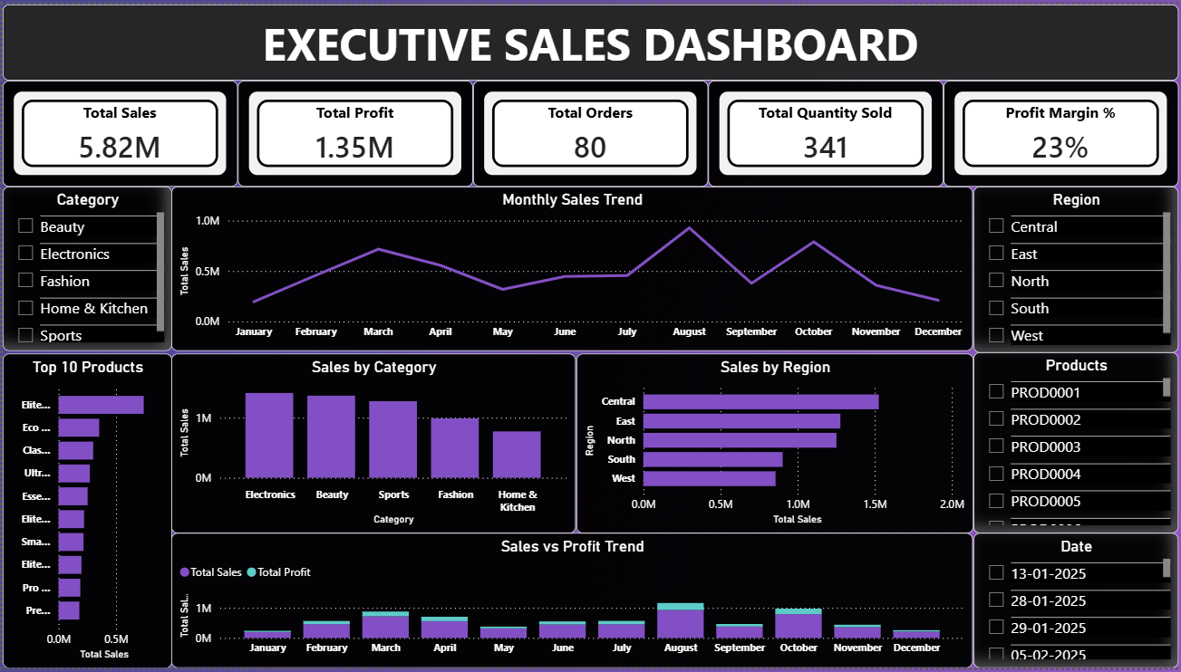

Dashboard Purpose

The dashboard enables management to quickly monitor overall sales performance and identify high-performing categories, products, regions, and periods.

PROFITABILITY & CUSTOMER INSIGHTS DASHBOARD
The second dashboard focuses on profitability, customers, and operational performance.

Main Components
- Total Profit
- Profit Margin
- Average Order Value
- Total Customers
- Average Selling Price
- Monthly Profit Trend
- Profit by Category
- Profit by Region
- Top 10 Customers
- Discount vs. Profit
- Order Status Distribution
- Interactive slicers

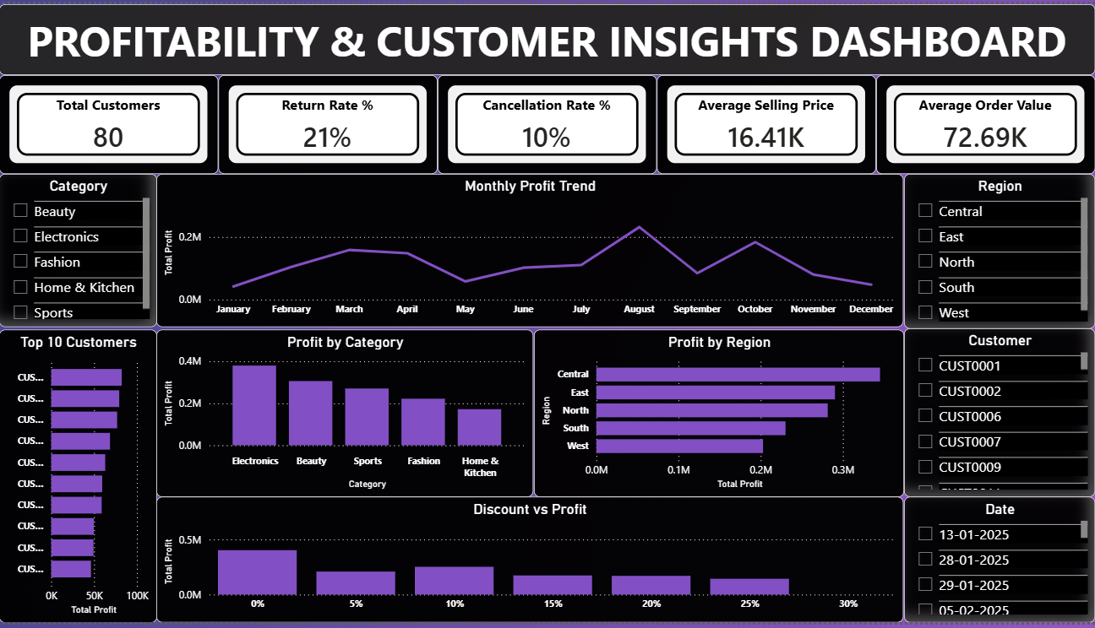

BUSINESS INSIGHTS

Sales Performance

Total Sales Reached 5.82M
Total Sales reached 5.82M, indicating the overall revenue generated by the business during the analysed period.
Business Action:
Focus on strategies to maintain and increase revenue.

Total Profit Reached 1.35M
Total Profit reached 1.35M, demonstrating a positive contribution from the recorded sales.
Business Action:
Focus on maintaining profitability and improving profit margins.

Electronics Generated the Highest Sales
Electronics generated the highest sales among all product categories.
Business Action:
Prioritize high-performing Electronics products in sales and marketing activities.

Central Region Recorded the Highest Sales
The Central region recorded the highest sales among all regions.
Business Action:
Analyse the success factors of the Central region and evaluate whether similar strategies can be applied to other regions.

August Recorded the Highest Monthly Sales
August recorded the highest monthly sales.
Business Action:
Identify the factors behind the August sales peak and evaluate whether successful patterns can be replicated.

Profitability

Electronics Generated the Highest Profit
Electronics generated the highest profit among the product categories.
Business Action:
Prioritize profitable Electronics products and maintain their availability.

Central Region Generated the Highest Profit
The Central region generated the highest profit.
Business Action:
Identify the factors driving Central-region profitability and evaluate opportunities to apply them elsewhere.

Sales and Profit Show a Similar Monthly Trend
Monthly sales and profit displayed a similar overall pattern.
Business Action:
Focus on sales growth strategies that also support profitable growth.

Profit Contribution Varies Across Product Categories
Profit contribution differed across product categories.
Business Action:
Review category-level margins and optimize the product mix.

Average Order Value is 72.69K
The Average Order Value was 72.69K.
Business Action:
Use upselling and cross-selling strategies to increase order value.

Customer & Operations

The Business Has 80 Recorded Customers
The dataset contains 80 recorded customers.
Business Action:
Focus on customer retention and repeat purchases.

The Dataset Contains 80 Recorded Orders
The analysis contains 80 recorded orders.
Business Action:
Analyse order frequency and identify opportunities to increase order volume.

Total Quantity Sold is 341 Units
A total of 341 units were recorded as sold.
Business Action:
Use demand patterns to improve inventory planning.

Return Rate is 21%
The overall Return Rate was 21%, requiring further investigation.
Business Action:
Identify products and categories with high return rates and investigate the underlying causes.

I Cancellation Rate is 10%
The overall Cancellation Rate was 10%, indicating an area for operational improvement.
Business Action:
Analyse cancellation reasons and improve the order fulfilment process.

ROOT CAUSE ANALYSIS

Electronics Generated the Highest Sales

Business Finding
Electronics generated the highest sales among all product categories.

RCA Investigation
- Product-level analysis identified Elite Audio Pack 14 as the highest sales-driving product within Electronics.
- Elite Audio Pack 14 generated 741,104.32 in sales from 22 units.
- Its selling price was 33,686.56 per unit.
- The highest regional sales contribution came from the East region, with 8 units generating 269,492.48.
- Customer-level analysis showed that CUST0017 purchased all 8 units in the East region.

Root Cause
Electronics' high sales were primarily driven by Elite Audio Pack 14, supported by strong unit sales. Its sales were particularly concentrated in the East region, where CUST0017 purchased 8 units.

Business Implication
Elite Audio Pack 14 is a key revenue-driving product. Management should maintain its availability and investigate opportunities to expand similar demand across other customers and regions.

Central Region Recorded the Highest Sales

Business Finding
The Central region recorded the highest sales among all regions.

RCA Investigation
- Product-level analysis identified Eco Outdoor Set 72 as the highest sales-driving product in Central.
- Eco Outdoor Set 72 generated 176,761.80 in sales from 6 units.
- Its selling price was 29,460.30 per unit.
- Customer-level analysis showed that CUST0013 purchased all 6 units in the Central region.
- Therefore, a significant portion of the product's Central-region sales was concentrated in a single customer.

Root Cause
Central-region sales were primarily supported by Eco Outdoor Set 72, with all 6 units purchased by CUST0013.

Business Implication
Management should maintain availability of high-performing products while expanding sales to additional customers to reduce customer concentration risk.

August Recorded the Highest Monthly Sales

Business Finding
August recorded the highest monthly sales.

RCA Investigation
- Product-level analysis identified Elite Equipment Set 80 as the largest contributor to August sales.
- The product generated 197,274.32 in sales from 8 units.
- Its selling price was 24,659.29 per unit.
- All 8 units were sold in the South region.
- Customer-level analysis showed that CUST0057 purchased all 8 units.

Root Cause
The August sales peak was primarily driven by Elite Equipment Set 80, with all 8 units sold in the South region to a single customer, CUST0057.

Business Implication
Management should investigate whether similar demand can be developed across other customers and regions to make future sales performance less dependent on individual transactions.

Electronics Generated the Highest Profit

Business Finding
Electronics generated the highest profit among all product categories.

RCA Investigation
- Elite Audio Pack 14 was identified as the highest profit-generating Electronics product.
- It generated 218,252.76 in total profit from 22 units.
- Its profit per unit was 9,920.58.
- The highest regional profit contribution came from the East region, generating 79,364.64 from 8 units.
- CUST0017 purchased all 8 East-region units.

Root Cause
Electronics' high profit was primarily driven by Elite Audio Pack 14, which combined a strong profit per unit with relatively high sales volume.

Business Implication
Elite Audio Pack 14 should be closely monitored as a key profit driver. Similar pricing, cost, and product-demand characteristics can be evaluated across other products.

Central Region Generated the Highest Profit

Business Finding
The Central region generated the highest profit.

RCA Investigation
- Elite Furniture Series 27 was identified as the highest profit-generating product in Central.
- It generated 44,844.35 in profit from 5 units.
- Its profit per unit was 8,968.87.
- CUST0051 purchased all 5 units.
- Therefore, the product's profit contribution was concentrated in one customer.

Root Cause
Central-region profitability was primarily supported by Elite Furniture Series 27, which generated strong profit per unit and was purchased entirely by CUST0051.

Business Implication
Management should maintain the performance of high-profit products while identifying similar customers to reduce dependency on a single customer.

Profit Contribution Varied Across Product Categories

Business Finding
Profit contribution varied significantly across product categories.

RCA Investigation
- Electronics generated the highest category-level profit at 379,746.60.
- Electronics sold 67 units, while Sports sold 75 and Beauty sold 72 units.
- Electronics had the highest average profit per unit at 5,667.86.
- Elite Audio Pack 14 was the largest Electronics profit contributor, generating 218,252.76 from 22 units.
- This indicates that Electronics' strong profitability was supported by both sales volume and profit per unit.

Root Cause
Differences in product profitability were driven by variations in sales volume and profit per unit. Electronics achieved the highest profit because it combined substantial volume with the highest average profit per unit, largely supported by Elite Audio Pack 14.

Business Implication
Management should identify the pricing, cost structure, and demand characteristics behind high-profit products and evaluate whether similar strategies can be applied to other categories.

Return Rate Was 21%

Business Finding
The overall return rate was 21%, indicating a potential operational issue requiring investigation.

RCA Investigation
- Product-level analysis showed that returns were distributed across multiple products and categories.
- The West region had the highest return rate at 50%, with 5 returned orders out of 10.
- The 5 returned orders were associated with 5 different customers.
- The 5 returned orders involved 5 different products across multiple categories.
- In the West region, 4 of the 5 returned orders used Debit Card.
- Debit Card transactions had an 80% return rate (4/5) in West, while Cash on Delivery had a 50% rate (1/2).

Root Cause
The dataset indicates that the West region is the primary return-risk area. Returns were spread across multiple customers and products rather than being concentrated in a single product or customer.
Debit Card transactions showed a high return rate, but the small sample size does not establish payment method as the direct cause.

Business Implication
Management should investigate West-region returns, particularly Debit Card transactions, and examine potential issues related to fulfilment, product condition, delivery experience, customer expectations, and return reasons.

Cancellation Rate Was 10%

Business Finding
The overall cancellation rate was 10%, indicating an area for operational improvement.

RCA Investigation
- The Central region had the highest cancellation rate at 17.39%, with 4 cancelled orders out of 23.
- The 4 cancelled orders involved 4 different products across multiple categories.
- The cancellations were associated with 4 different customers.
- Payment-method analysis showed:
  - Debit Card → 2 cancellations
  - UPI → 1 cancellation
  - Net Banking → 1 cancellation
- Within Central, Debit Card had the highest cancellation rate at 40% (2/5).
- UPI had a 25% cancellation rate, while Net Banking had 12.50%.

Root Cause
Central region represents the primary cancellation-risk area. Cancellations were distributed across multiple products and customers rather than being caused by a single product or customer.
Debit Card transactions showed a higher cancellation rate, suggesting a possible association, but the dataset is too small to establish a direct causal relationship.

Business Implication
Management should investigate Central-region cancellations, particularly Debit Card orders, focusing on payment processing, order confirmation, fulfilment, stock availability, and customer experience.

BUSINESS RECOMMENDATIONS

Strengthen High-Performing Electronics Products

Based on Finding
Electronics generated the highest sales, primarily driven by Elite Audio Pack 14.

Recommendation
Management should maintain sufficient inventory and availability of high-performing Electronics products, particularly Elite Audio Pack 14. The company should also analyse the pricing, demand, and product characteristics that contribute to its strong performance and identify opportunities to replicate these factors across other Electronics products.

Expected Business Impact
- Maintain strong revenue performance
- Reduce the risk of stock outs
- Improve Electronics category growth
- Increase sales from other high-potential products

Reduce Customer Concentration in the Central Region

Based on Finding
Central region recorded the highest sales, with significant contribution from Eco Outdoor Set 72 and CUST0013.

Recommendation
Management should expand sales of high-performing products in the Central region to a broader customer base. The company should identify similar customer segments and develop targeted sales and marketing strategies instead of relying heavily on individual customers.

Expected Business Impact
- Reduce customer concentration risk
- Improve customer acquisition
- Create more stable regional revenue
- Increase Central-region growth potential

Replicate August's High-Performing Sales Patterns

Based on Finding
August recorded the highest monthly sales, primarily driven by Elite Equipment Set 80, with strong sales concentrated in the South region.

Recommendation
Management should analyse the demand patterns behind August's performance and identify whether similar product demand can be generated in other months, regions, and customer segments.

Expected Business Impact
- Improve monthly sales consistency
- Reduce dependency on one-time sales peaks
- Increase demand for high-performing products
- Improve sales forecasting and inventory planning

Focus on High-Profit Products

Based on Finding
Electronics generated the highest profit, with Elite Audio Pack 14 being the major profit contributor.

Recommendation
Management should prioritize high-profit products such as Elite Audio Pack 14 while carefully monitoring pricing, cost structure, and demand.

Expected Business Impact
- Improve overall profitability
- Increase profit contribution from high-margin products
- Support better pricing decisions
- Improve product portfolio profitability

Diversify High-Profit Customer Contributions in Central

Based on Finding
Central region generated the highest profit, with Elite Furniture Series 27's contribution concentrated in CUST0051.

Recommendation
Management should reduce dependency on individual high-value customers by identifying and targeting similar customers in the Central region.

Expected Business Impact
- Reduce customer concentration risk
- Improve revenue and profit stability
- Increase customer base
- Create opportunities for sustainable regional growth

Replicate High-Profit Product Characteristics across Categories

Based on Finding
Profit contribution varies across categories, with Electronics achieving the highest profit and average profit per unit.

Recommendation
Management should analyse the pricing, cost structure, product demand, and sales volume of high-profit products and evaluate whether similar characteristics can be applied to lower-profit categories.

Expected Business Impact
- Improve category-level profitability
- Increase profit margins
- Optimize product mix
- Support better pricing and cost management

Investigate High Return Risk in the West Region

Based on Finding
Overall return rate was 21%, while the West region recorded the highest return rate at 50%.

Recommendation
Management should conduct a detailed investigation of returned orders in the West region, particularly Debit Card transactions.
The company should analyse:
- Return reasons
- Delivery issues
- Product condition
- Fulfilment problems
- Customer expectations
- Payment-method patterns
Payment-method patterns should be monitored using a larger dataset before concluding that payment method is a direct cause.

Expected Business Impact
- Reduce return rates
- Improve customer satisfaction
- Identify operational problems
- Reduce revenue leakage associated with returns

Reduce Order Cancellations in the Central Region

Based on Finding
Overall cancellation rate was 10%, while Central recorded the highest cancellation rate at 17.39%.

Recommendation
Management should investigate the causes of cancellations in the Central region, particularly Debit Card orders.
The company should review:
- Payment processing
- Order confirmation
- Stock availability
- Fulfilment
- Customer communication

Expected Business Impact
- Reduce order cancellation rate
- Improve order fulfilment
- Improve customer experience
- Reduce lost sales opportunities
- Improve operational efficiency

CONCLUSION
The E-Commerce Sales & Customer Analytics project demonstrates an end-to-end practical data analytics process, beginning with raw transactional data and progressing toward actionable business recommendations.
The analysis combined Excel, Power Query, SQL, Power BI, and DAX to clean, transform, model, analyse, and visualize the data.
The analysis identified several significant findings. Total sales reached 5.82M, while total profit reached 1.35M, resulting in an overall profit margin of approximately 23%.
Electronics emerged as the leading category in both sales and profitability, while the Central region recorded the highest sales and profit. August represented the peak sales month.
The analysis also identified operational areas requiring attention. The overall return rate was 21%, with the West region showing the highest return risk. The cancellation rate was 10%, with the Central region showing the highest cancellation rate.
SQL-based Root Cause Analysis provided deeper insight into the products, customers, regions, and payment methods contributing to these patterns.
Based on these findings, recommendations were developed to strengthen high-performing products, diversify customer concentration, improve profitability, replicate successful sales patterns, and address return and cancellation risks.
Overall, the project demonstrates how data analytics can transform raw business data into meaningful insights that support data-driven decision-making and business performance improvement.

LIMITATIONS
The project has several limitations that should be considered when interpreting the findings.

Dataset Size
The dataset contains a relatively limited number of records. Therefore, some observed patterns may not represent long-term business behaviour.

Limited Historical Coverage
The available dataset covers a limited period, which restricts long-term trend analysis and seasonality assessment.

Return and Cancellation Reasons
The dataset does not contain detailed return or cancellation reasons. Therefore, the Root Cause Analysis identifies patterns and potential contributing factors rather than definitive causal explanations.

Small Sample Size for Payment Analysis
Some payment-method and regional combinations contain a small number of transactions. Therefore, observed relationships should not be interpreted as direct causal relationships.

Synthetic / Portfolio Dataset
The project is designed as a practical portfolio analysis. Therefore, the results should be interpreted as analytical demonstrations rather than actual business performance.

FUTURE SCOPE
The project can be extended through more advanced analytics.
Potential future improvements include:

Sales Forecasting
Develop time-series forecasting models to predict future sales.

Customer Segmentation
Segment customers based on purchasing behaviour, order value, frequency, and profitability.

Customer Lifetime Value
Calculate Customer Lifetime Value to identify the most valuable long-term customers.

Predictive Return Analysis
Develop models to identify orders or products with a high probability of return.

Cancellation Prediction
Analyse historical patterns to predict orders at risk of cancellation.

Advanced Profitability Analysis
Develop product-level and customer-level profitability models.

Inventory Optimization
Combine sales patterns with product demand to improve inventory planning.

Automated Reporting
Automate data refresh and dashboard reporting for regular management use.

